STRAVA FITNESS DATA ANALYTICS CASE-STUDY


For submission

- Streamlit app → dashboard, → in the streamlit app SQL Analysis
- Record a video

- Clean the data - SQL,(insights →)

- POWERBI - dashboard / Tableau

- Python (Matplotlib, seaborn)- to visualize

Case Study: How Can a Wellness Technology Company
Play It Smart?
Background
Bellabeat, a high-tech manufacturer of health-focused products for women. Bellabeat is a successful small
company, but they have the potential to become a larger player in the global smart device market. Urška Sršen, co- founder and Chief Creative Officer of Bellabeat, believes that analyzing smart device fitness data could help unlock new growth opportunities for the company.
Urška Sršen and Sando Mur founded Bellabeat, a high-tech company that manufactures health-focused smart
products. Sršen used her background as an artist to develop beautifully designed technology that informs and inspires women around the world. Collecting data on activity, sleep, stress, and reproductive health has allowed Bellabeat to empower women with knowledge about their own health and habits. Since it was founded in 2013,

Bellabeat has grown rapidly and quickly positioned itself as a tech-driven wellness company for women. Sršen knows that an analysis of Bellabeat’s available consumer data would reveal more opportunities for growth. She has asked the marketing analytics team to focus on a Bellabeat product and analyze smart device usage data in order to gain insight into how people are already using their smart devices. Then, using this information, she would like high-level recommendations for how these trends can inform Bellabeat marketing strategy.
You have been asked to focus on one of Bellabeat’s products and analyze smart device data to gain insight into how consumers are using their smart devices. The insights you discover will then help guide marketing strategy for the company. You will present your analysis to the Bellabeat executive team along with your high-level recommendations for Bellabeat’s marketing strategy.

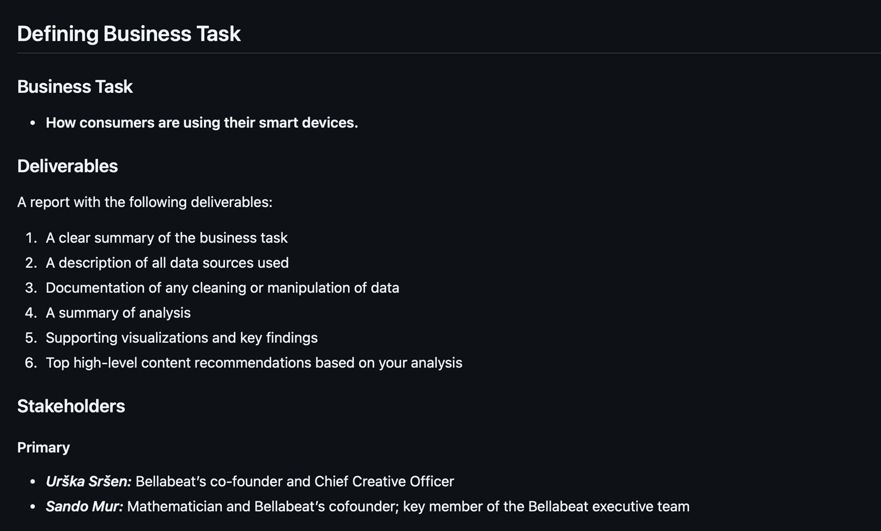

Secondary

Bellabeat marketing analytics team: A team of data analysts responsible for collecting, analyzing, and reporting data that helps guide Bellabeat’s marketing strategy. You joined this team six months ago and have been busy learning about Bellabeat’’s mission and business goals — as well as how you, as a junior data analyst, can help Bellabeat achieve them.

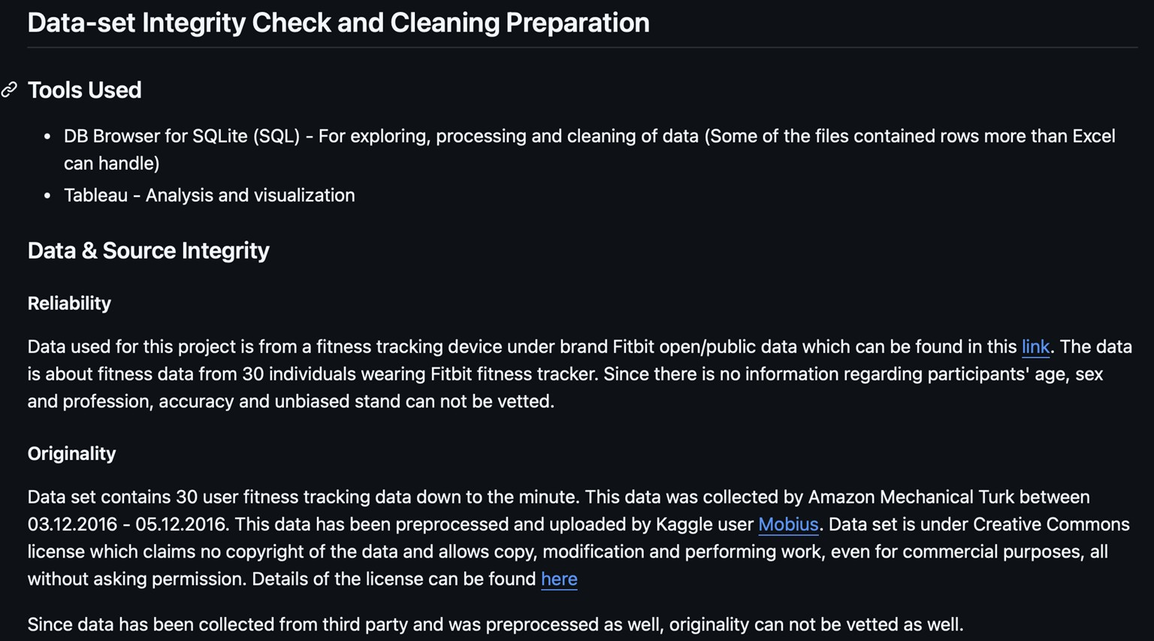

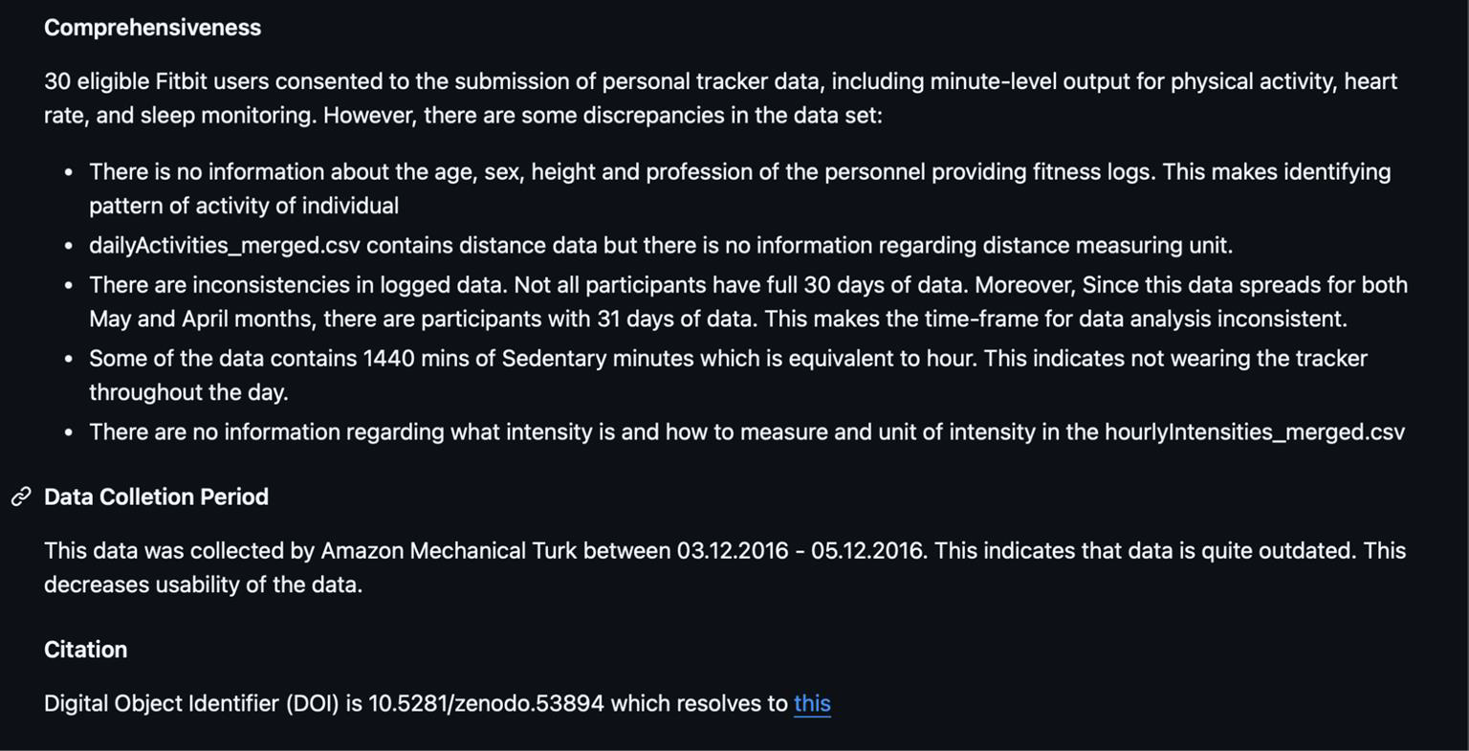

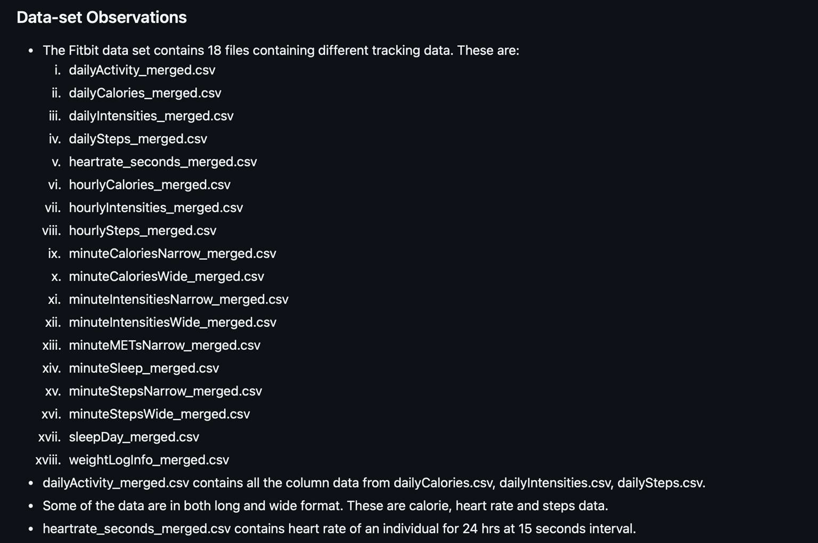

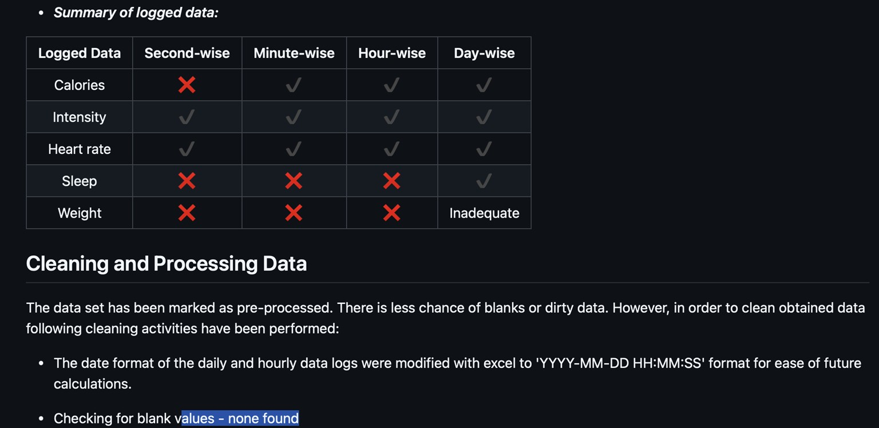

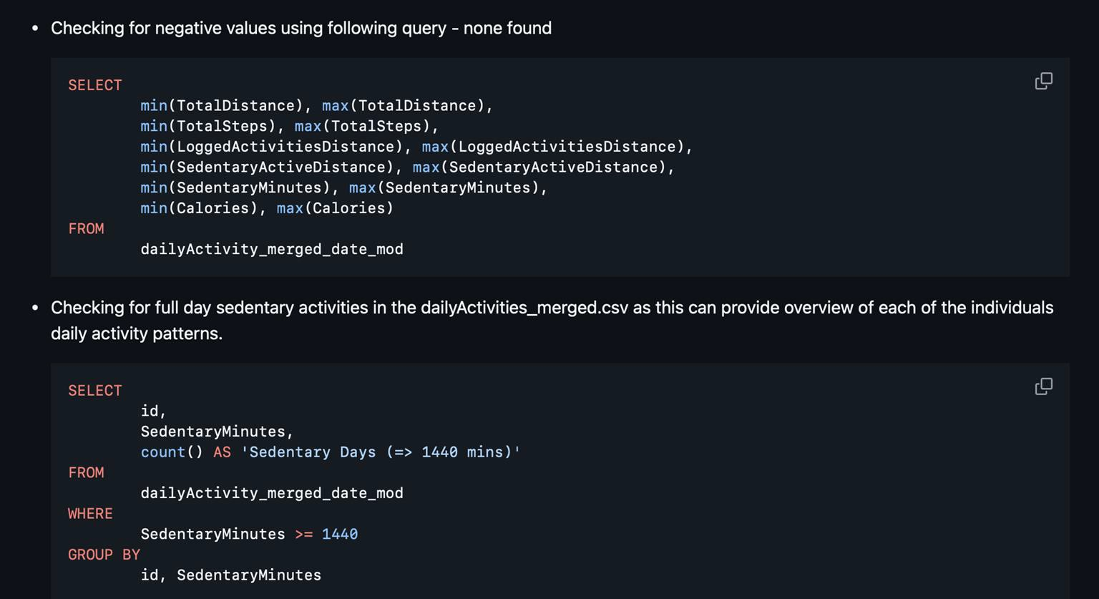

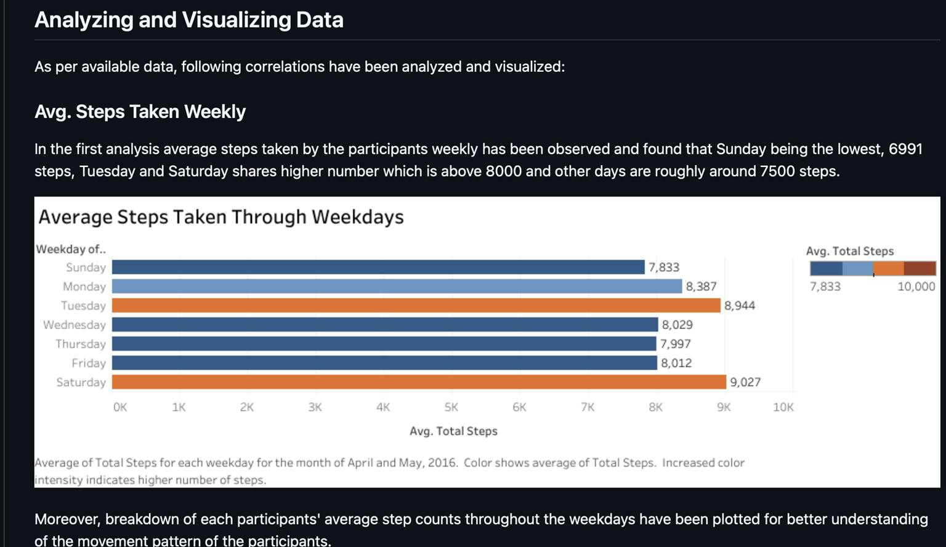

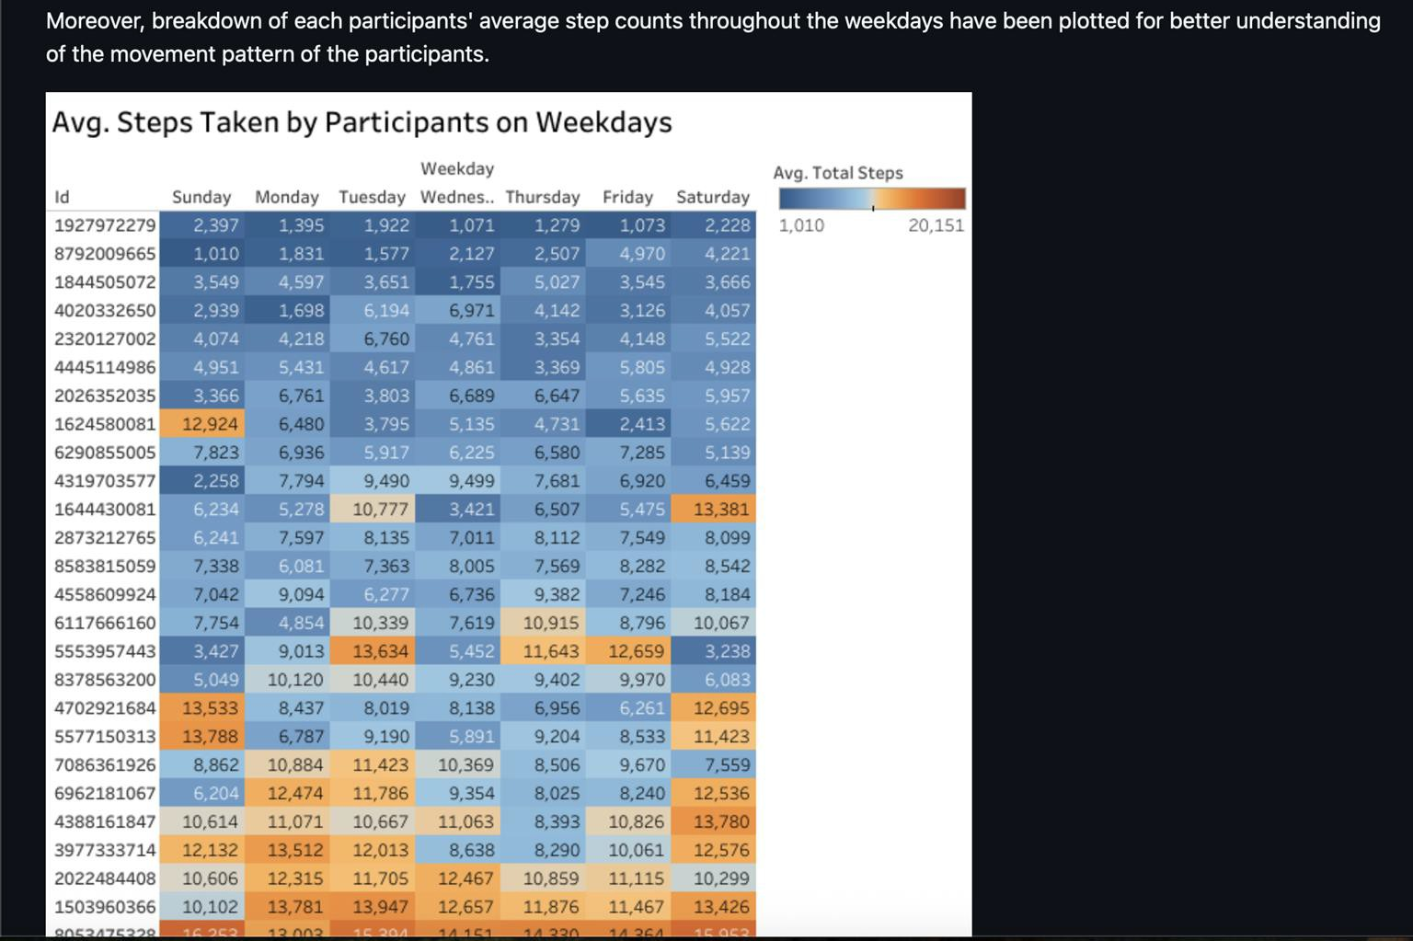

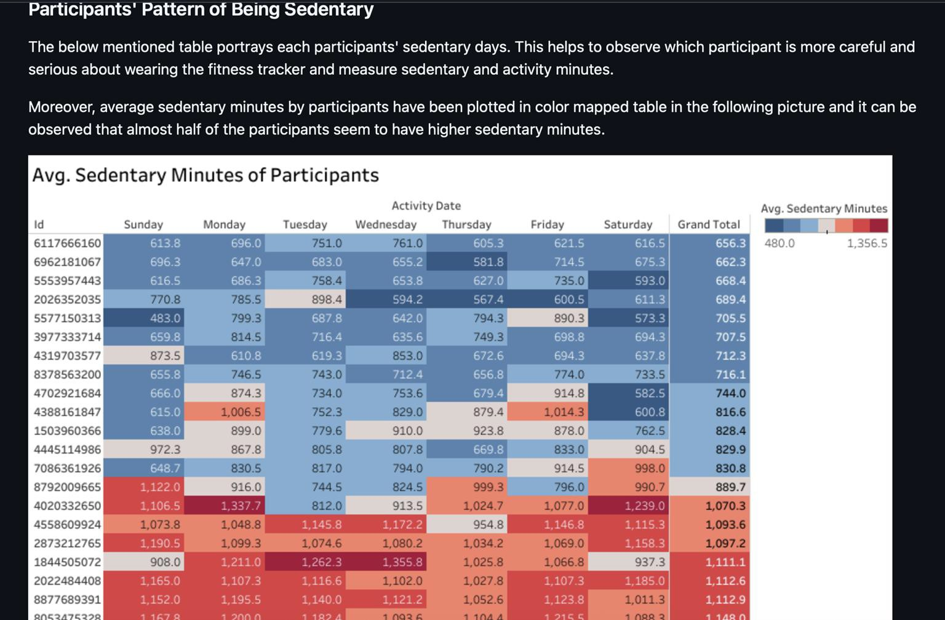

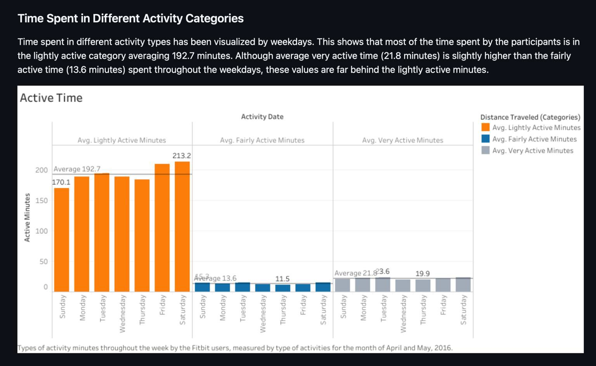

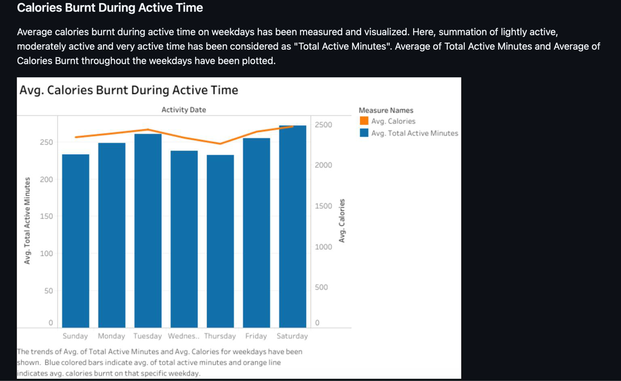

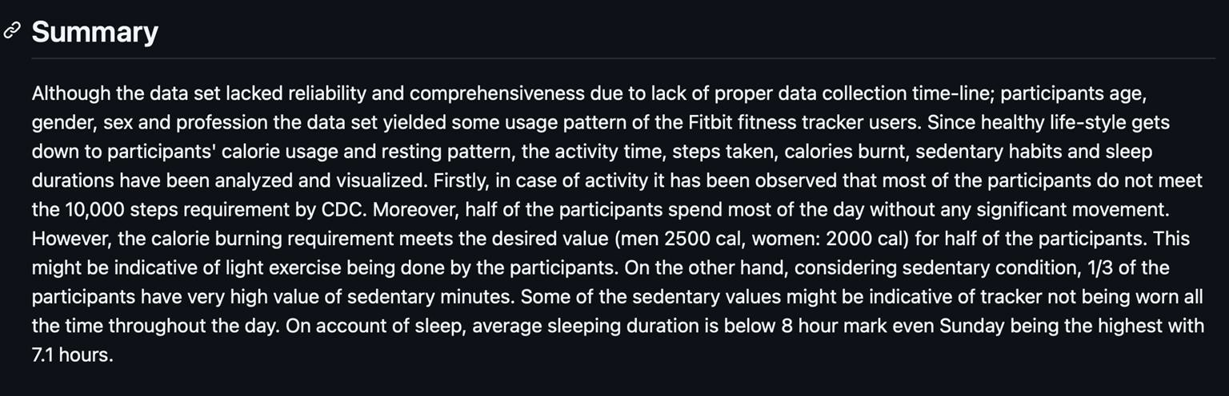

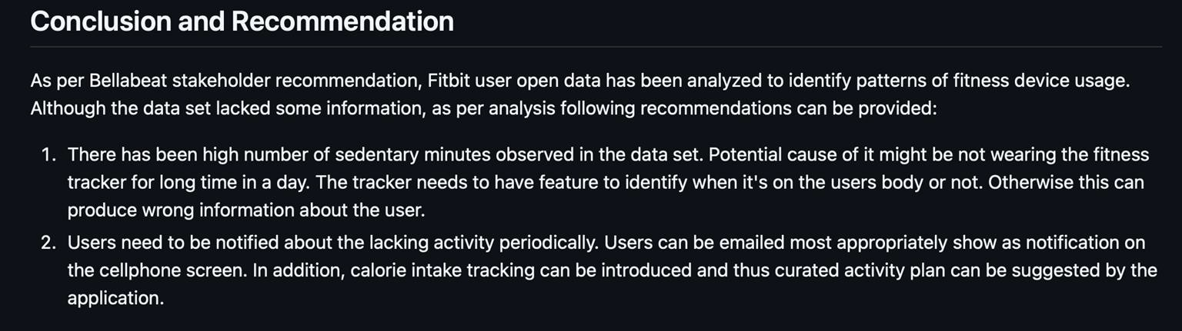

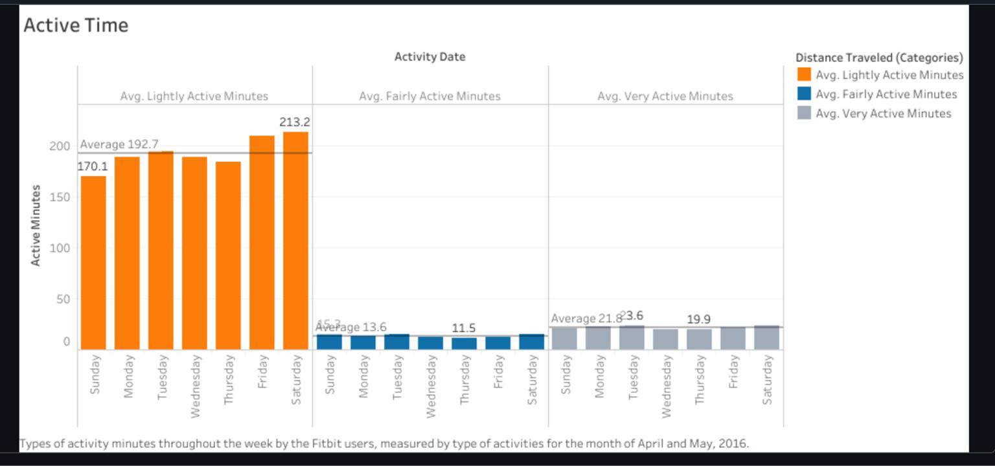

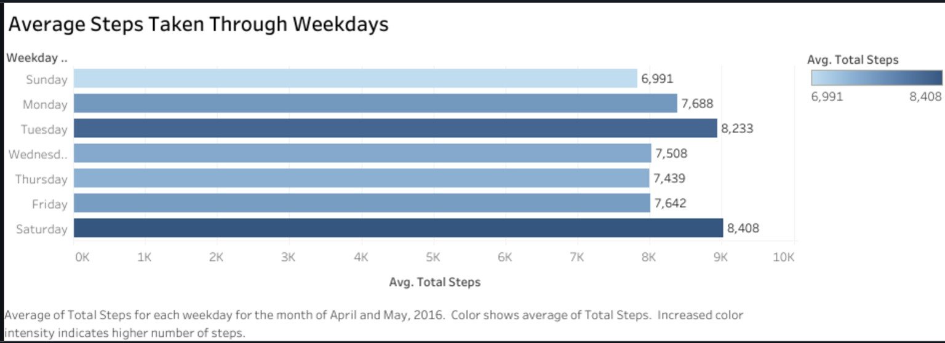

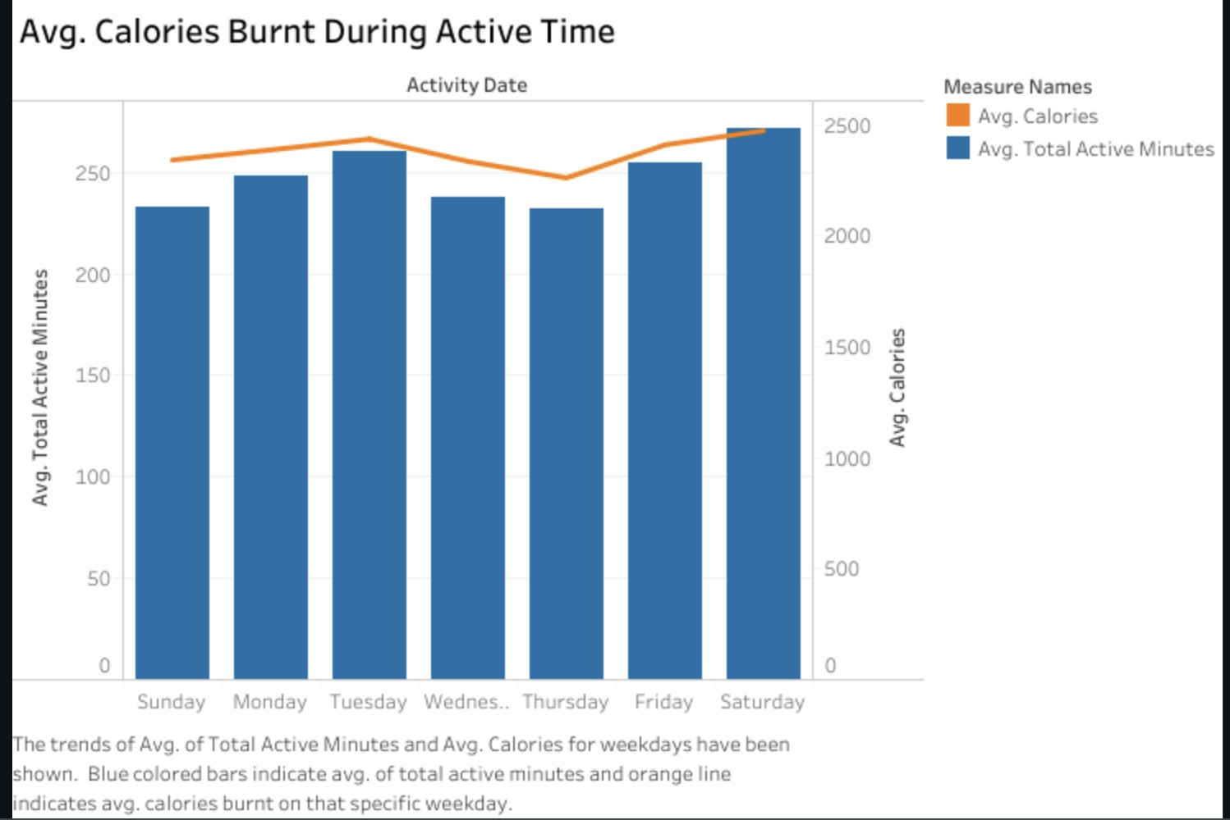

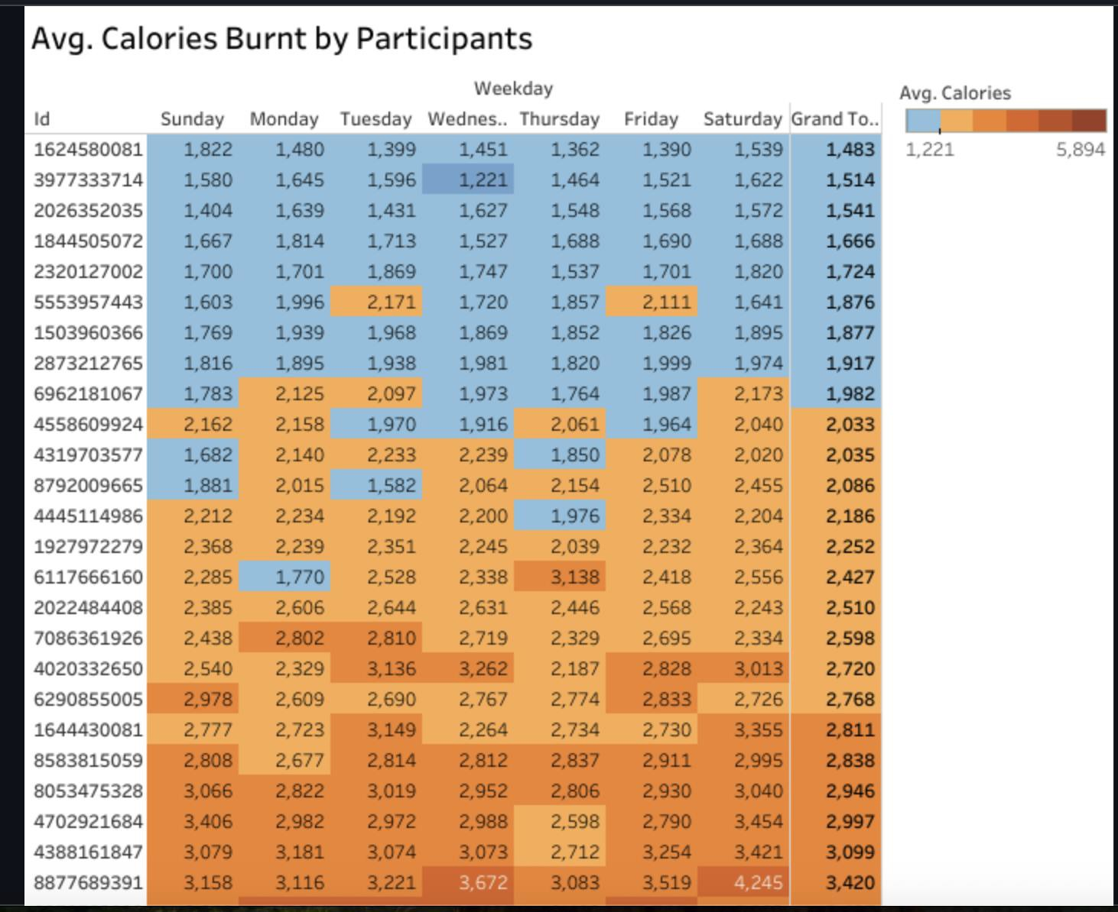

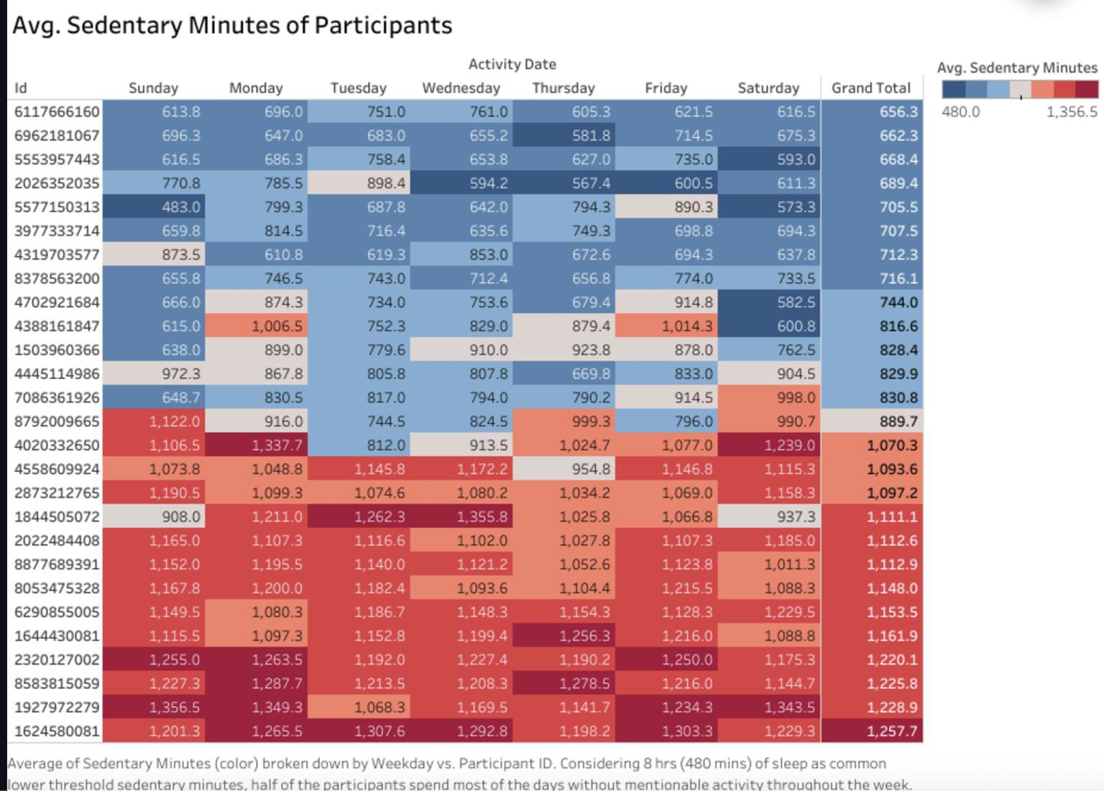

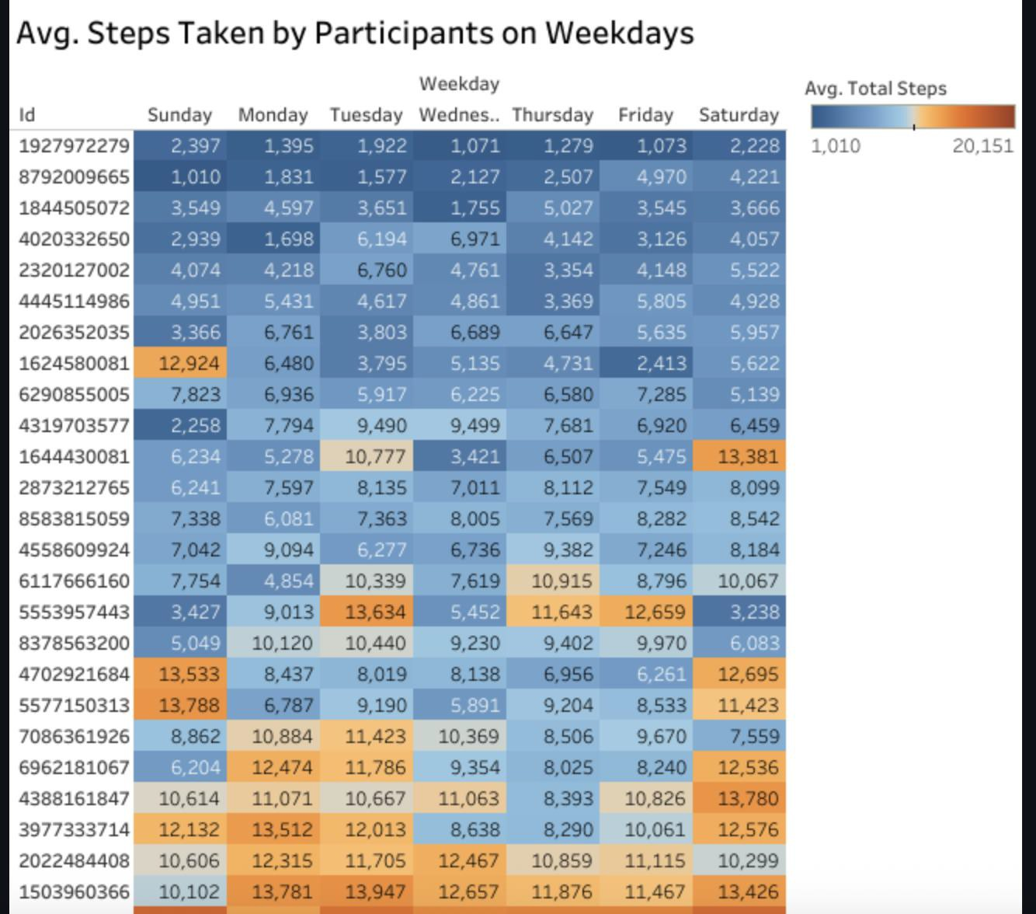

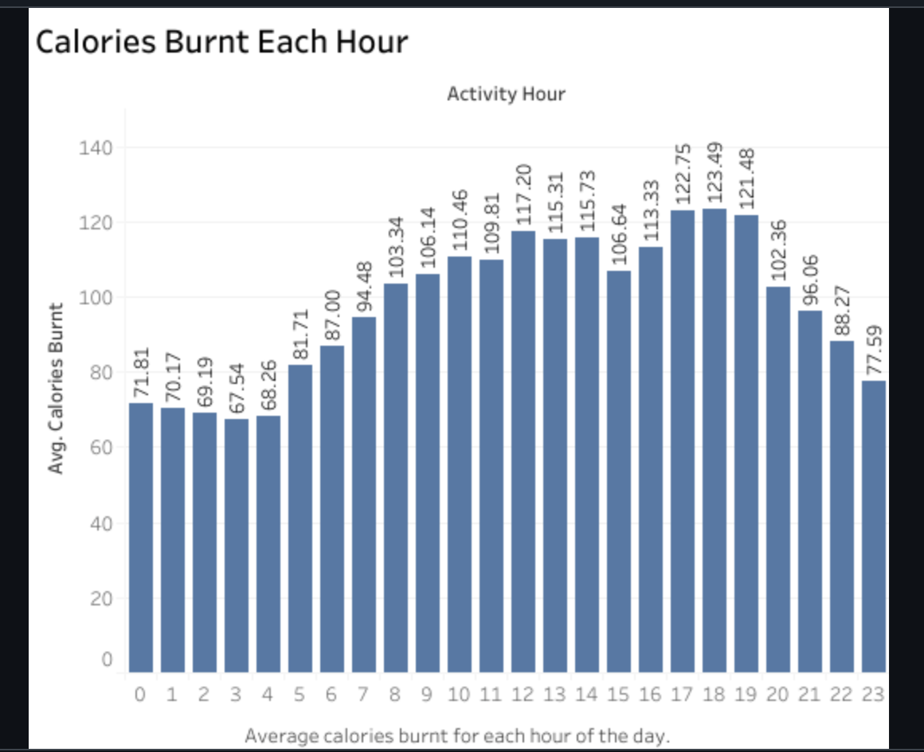

References

Lifestyle Coach Facilitation Guide: Post-Core:
https://www.cdc.gov/diabetes/prevention/pdf/postcurriculum_session8.pdf
- Examples of Moderate and Vigorous Physical Activity: https://www.hsph.harvard.edu/obesity-prevention-source/moderate-and-vigorous- physical-activity/
- How Many Calories Should You Burn Daily: https://www.nike.com/a/how-many-

calories-should-you-burn-daily
- How Much Sleep Do I Need?: https://www.cdc.gov/sleep/about_sleep/how_much_sleep.html

